29.52: a) The flux through the coil is given by 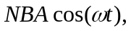 where  is the number of turns, is the strength of the Earth’s magnetic field, and is the angular velocity of the rotating coil. Thus, 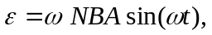 which has a peak amplitude of 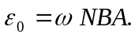 Solving for  we obtain

b) Assuming a point on the coil at maximum distance from the axis of rotation we have

